Steps to submit request for DB password reset and Db user creation

Step1 – Open tech assist portal

Link - https://anztech.service-now.com/techassist

Search for generic work request

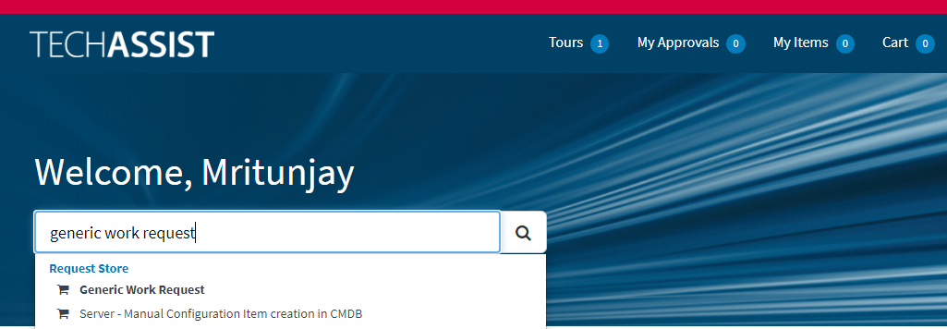

Step – 2

Go to generic work request

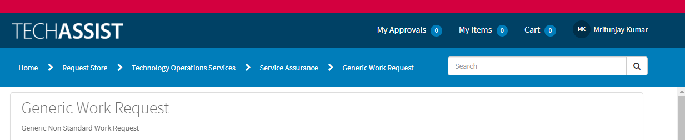

Step – 3

Fill all the details as per the requirement

Ex-

Request Title – DB Access password Reset or create new user

Request Details – user Id, DB Name, DB server name

Fulfilment group – ICS – Platform + Enablement – Non-Prod oracle Support



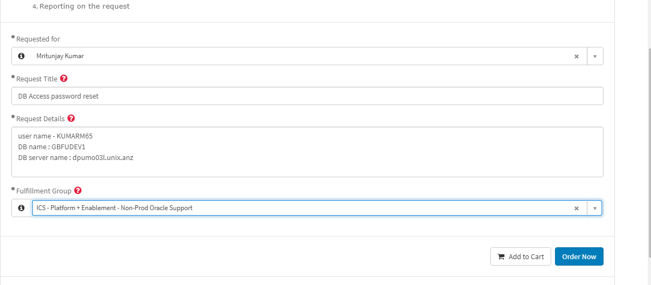

Step – 4

Click on order now

Then click on checkout

